# Tools for Data Science

## Overview of Git/GitHub

In this video, you’ll get an overview of Git and GitHub, which are popular environments among developers and data scientists for performing version control of source code files and projects and collaborating with others. You can’t talk about Git and GitHub without a basic understanding of what version control is.

Play video starting at ::30 and follow transcript0:30

A version control system allows you to keep track of changes to your documents. This makes it easy for you to recover older versions of your document if you make a mistake, and it makes collaboration with others much easier. Here is an example to illustrate how version control works. Let’s say you’ve got a shopping list and you want your roommates to confirm the things you need and add additional items. Without version control, you’ve got a big mess to clean up before you can go shopping. With version control, you know EXACTLY what you need after everyone has contributed their ideas.

Play video starting at :1:9 and follow transcript1:09

Git is free and open source software distributed under the GNU General Public License. Git is a distributed version control system, which means that users anywhere in the world can have a copy of your project on their own computer; when they’ve made changes, they can sync their version to a remote server to share it with you. Git isn’t the only version control system out there, but the distributed aspect is one of the main reasons it’s become one of the most common version control systems available. Version control systems are widely used for things involving code, but you can also version control images, documents, and any number of file types. You can use Git without a web interface by using your command line interface, but GitHub is one of the most popular web-hosted services for Git repositories. Others include GitLab, BitBucket, and Beanstalk. There are a few basic terms that you will need to know before you can get started. The SSH protocol is a method for secure remote login from one computer to another. A repository contains your project folders that are set up for version control. A fork is a copy of a repository. A pull request is the way you request that someone reviews and approves your changes before they become final. A working directory contains the files and subdirectories on your computer that are associated with a Git repository. There are a few basic Git commands that you will always use. When starting out with a new repository, you only need create it once: either locally, and then push to GitHub, or by cloning an existing repository by using the command "git init".

Play video starting at :3:3 and follow transcript3:03

"git add" moves changes from the working directory to the staging area. "git status" allows you to see the state of your working directory and the staged snapshot of your changes. "git commit" takes your staged snapshot of changes and commits them to the project. "git reset" undoes changes that you’ve made to the files in your working directory. "git log" enables you to browse previous changes to a project. "git branch" lets you create an isolated environment within your repository to make changes. "git checkout" lets you see and change existing branches. "git merge" lets you put everything back together again. To learn how to use Git effectively and begin collaborating with data scientists around the world, you will need to learn the essential commands. Luckily for us, GitHub has amazing resources available to help you get started. Go to try.github.io to download the cheat sheets and run through the tutorials. In the following modules, we'll give you a crash course on setting up your local environment and getting started on a project.

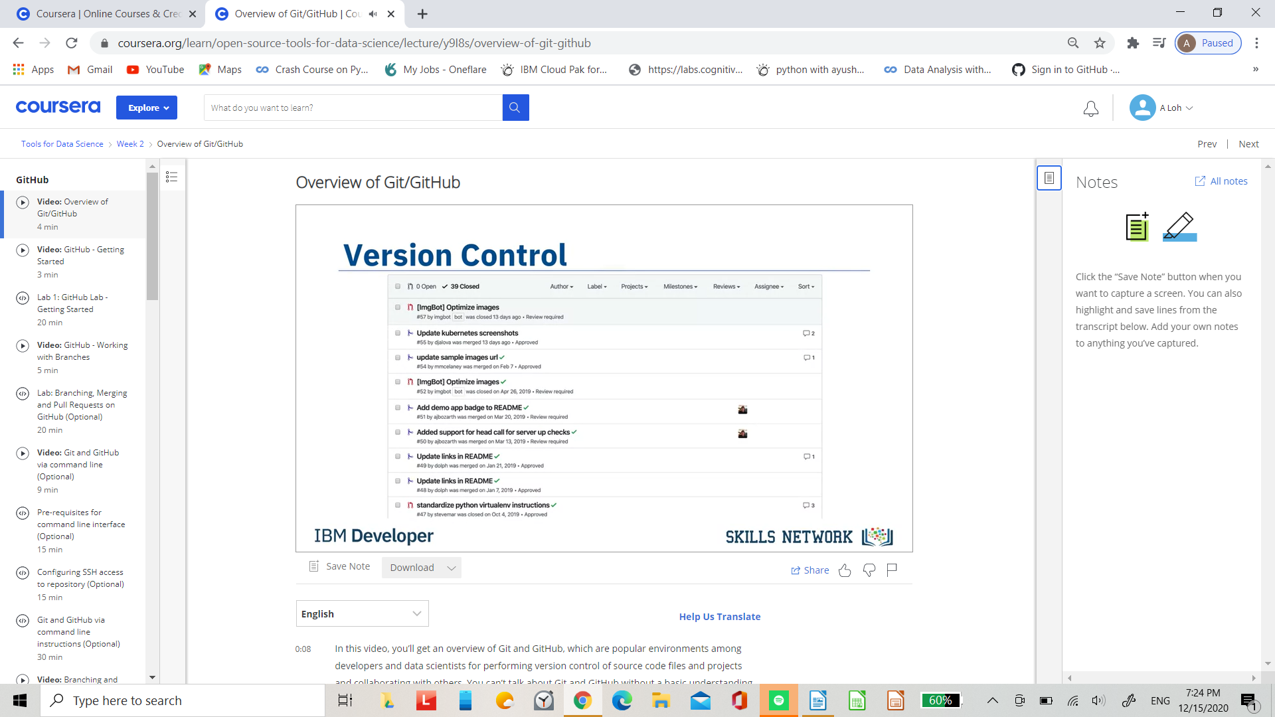

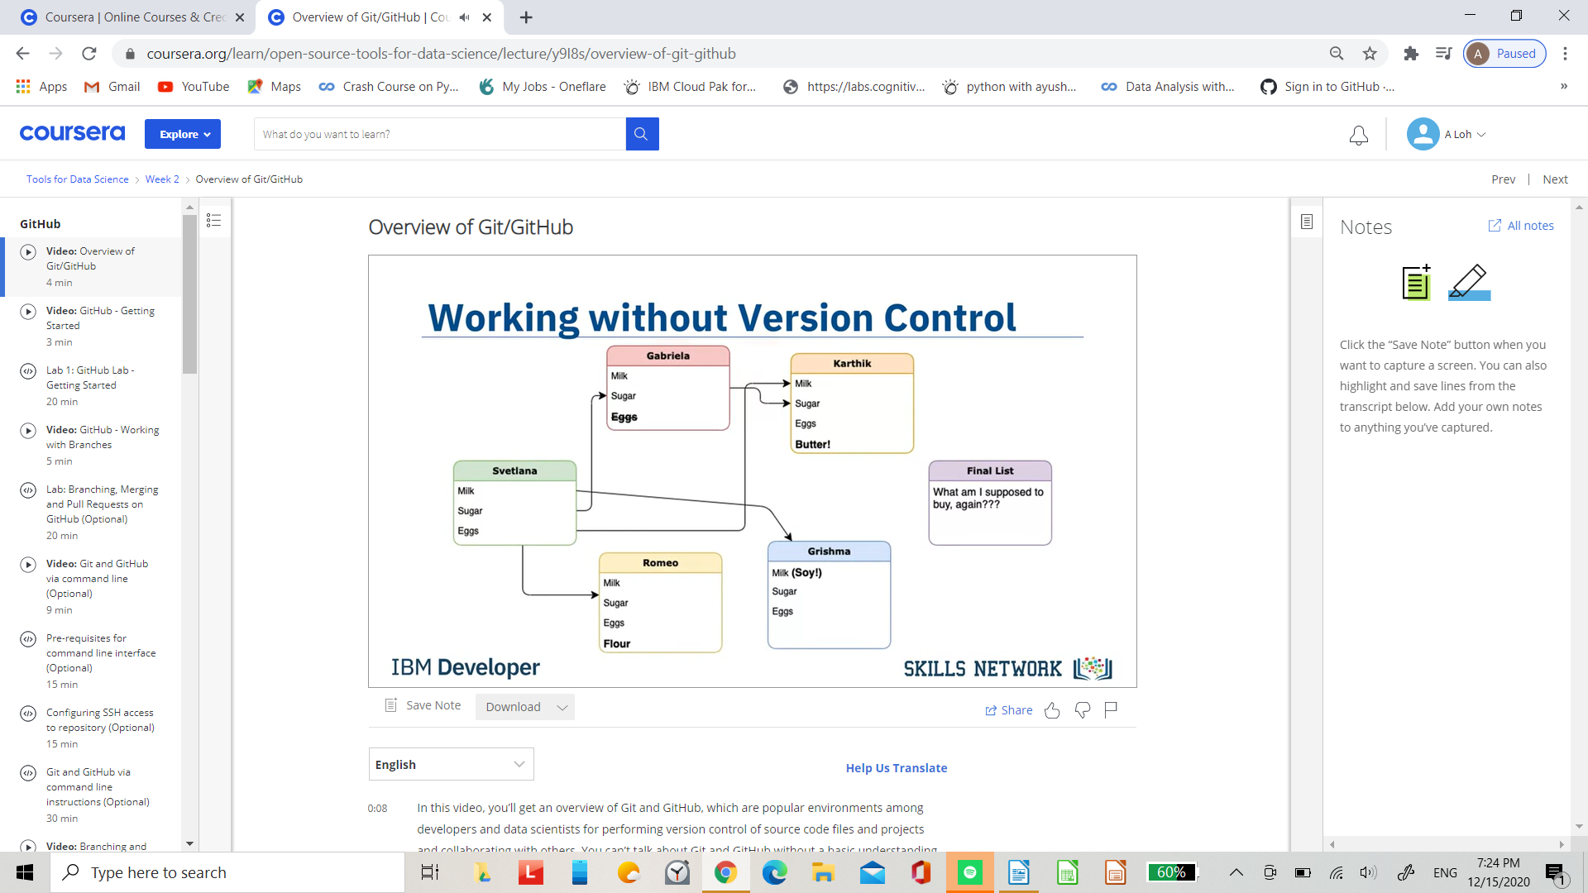

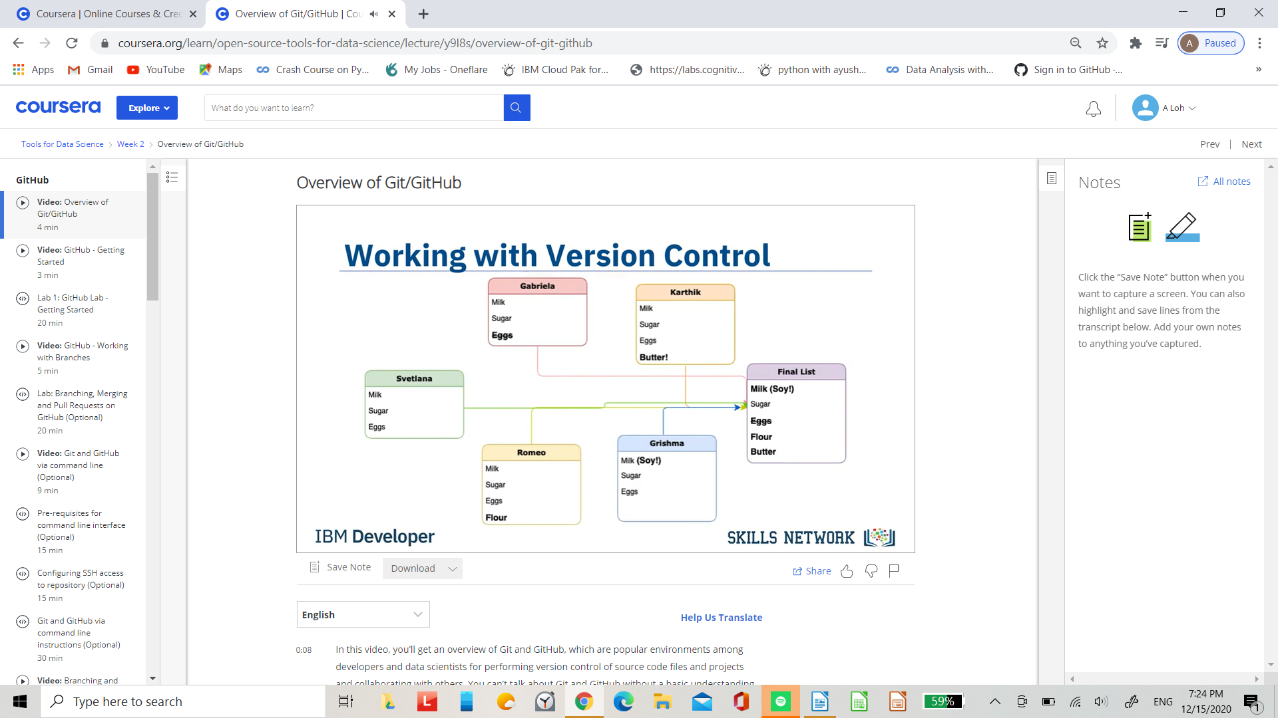.

Git run under General Public Licence

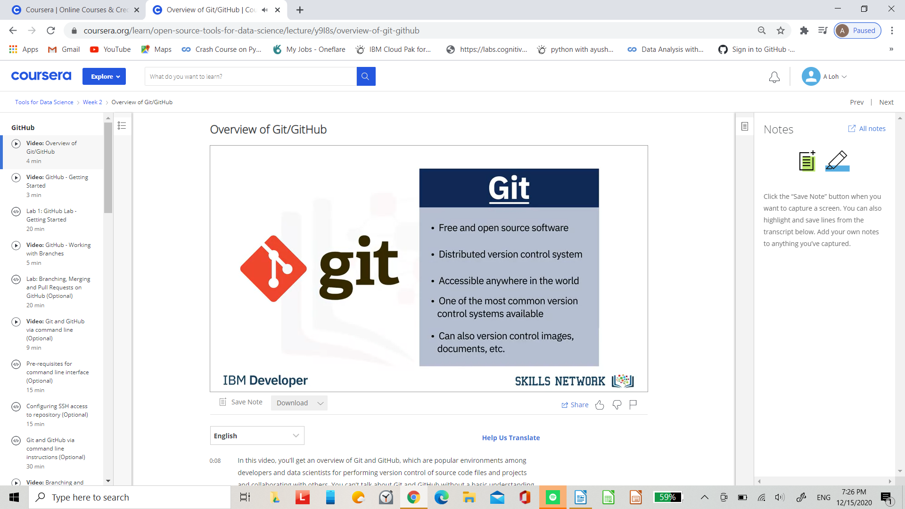.

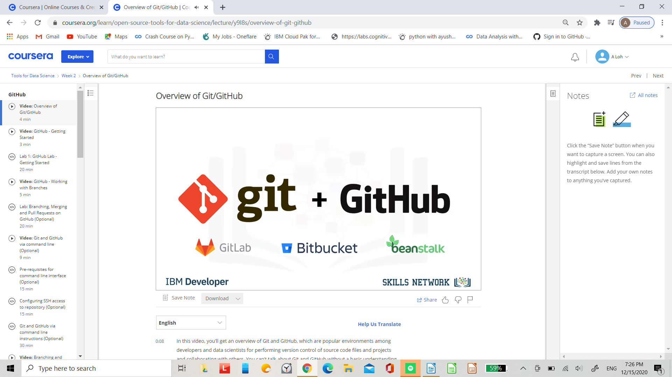.

Glossary

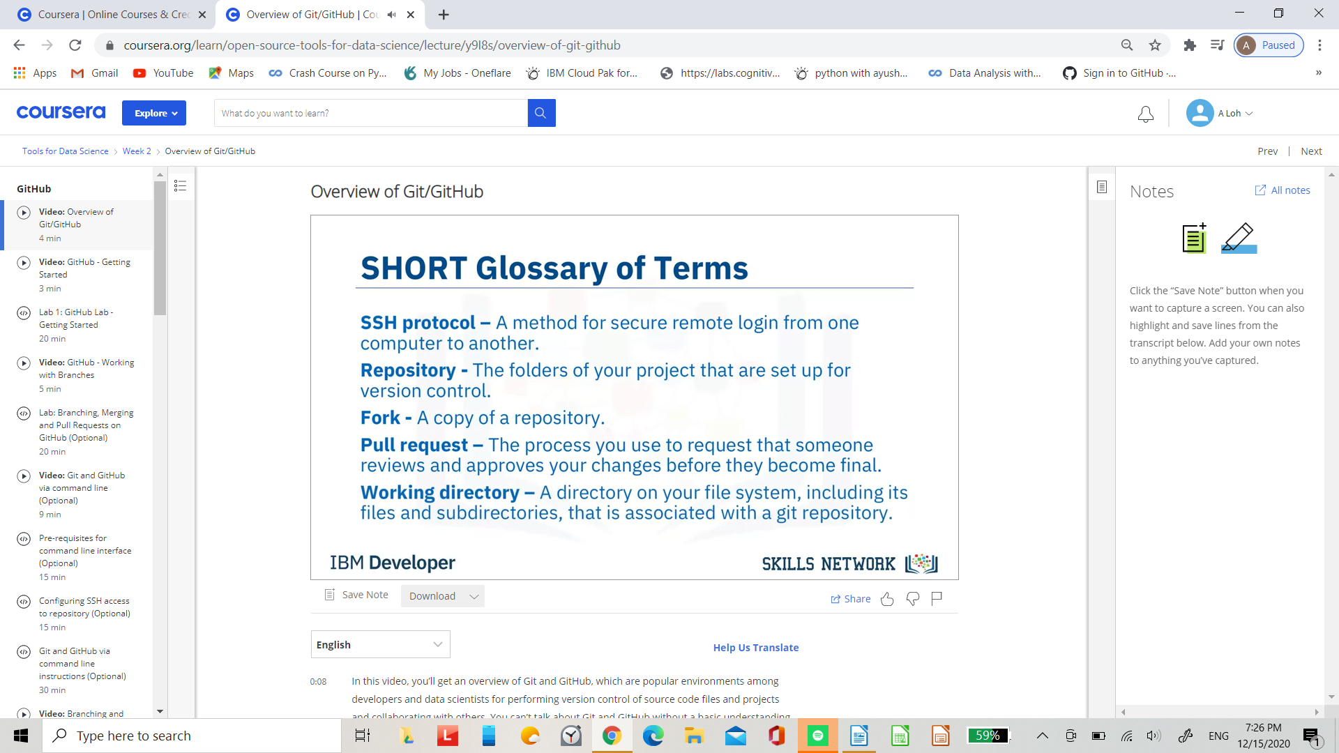.

Commands

git init…

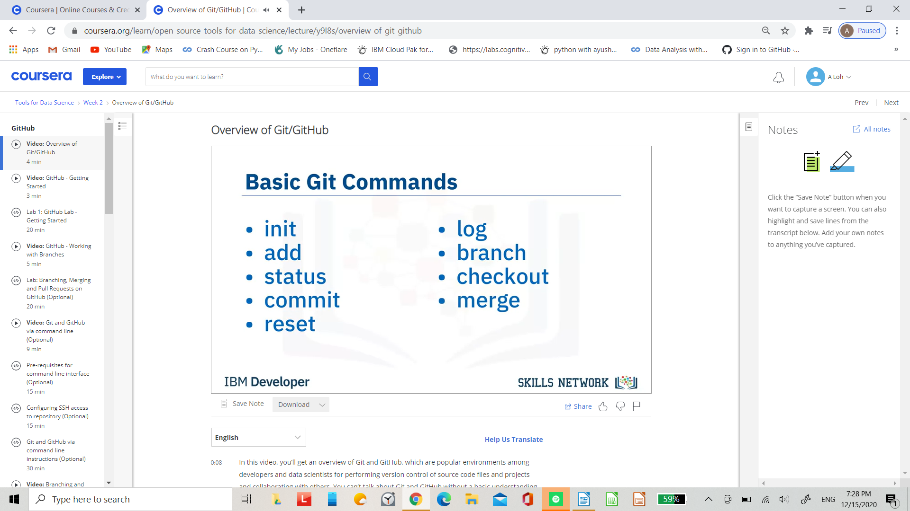.

cheat sheet https://try.github.io/

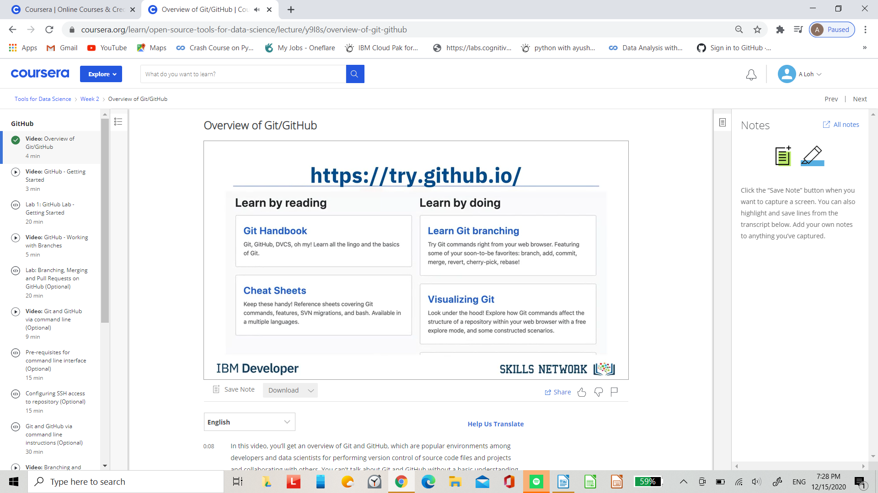.

## GitHub - Getting Started

In the previous video, you learned about Git and GitHub. Before you continue with this video, register for a GitHub account and log in. Let’s start by creating a new repository. Click + then click New Repository. To create a new repository, you need to provide these details: give your new repository a name; optionally, add a description of your repository; choose the repository visibility - whether you want it to be public or private; and choose the option to Initialize this repository with readme file. Then click Create Repository.

Play video starting at ::54 and follow transcript0:54

You will now be redirected to the repository you have created. The root folder of your repository is listed by default and it has just one file ReadMe.md.

Play video starting at :1:8 and follow transcript1:08

Now, it’s time to edit the readme. You can do this in your browser. Just click the pencil to open the online editor and you can change the text of the readme. To save your changes to the repository, you must commit them. After you have made your changes, scroll down to the Commit changes section. Add a commit message and optionally add a description, then click Commit changes. The "commit changes" is used to save your changes to the repository. Go back to the home screen by clicking the repository name link. Note that the readme file is updated and verify your changes.

Play video starting at :1:49 and follow transcript1:49

Let’s learn how to create a new file using the built-in web editor provided by GitHub which runs in the browser. Click Add File, then click Create New File to create the new file.

Play video starting at :2:4 and follow transcript2:04

To create a python file called firstpython.py. First, provide the file name. Next, add a comment that describes your code, then add the code.

Play video starting at :2:17 and follow transcript2:17

Once finished, commit the change to the repository. You can see that your file is now added to the repository and the repository listing shows when the file was added or changed. When you need to change the file, you can edit it again. Click the file name, and then click the pencil icon, make your edits and commit the changes.

Play video starting at :2:40 and follow transcript2:40

You can also upload a file from your local system into the repository. From the home screen of the repository, click Add File and choose the Upload files option.

Play video starting at :2:53 and follow transcript2:53

Click Choose Your Files and select the files you want to upload from your local system.

Play video starting at :2:59 and follow transcript2:59

The file upload process may take a short time, depending on what you are uploading. Once the files finish uploading, click Commit Changes. The repository now reflects the files that were uploaded. In this video, you learned how to create a repository, edit files, and commit changes using the web interface.

